Contenido

LO QUE DEBO APRENDER 1

Comandos SQL 1

1. Crear tabla 1

# LO QUE DEBO APRENDER

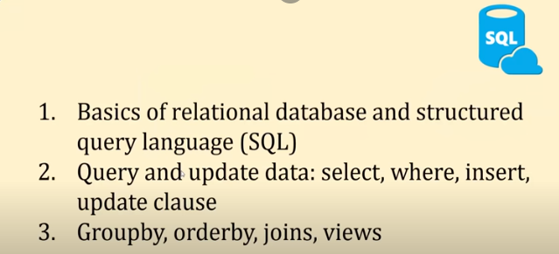

# Comandos SQL

**Fuente:** <https://www.khanacademy.org/computing/computer-programming/sql/sql-basics/pt/creating-a-table-and-inserting-data>

**Fuente:** <https://www.youtube.com/playlist?list=PL08903FB7ACA1C2FB> (12 primeros)

## Crear tabla

Sin incremento automático

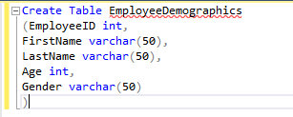

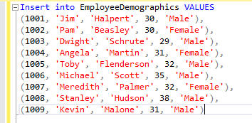

Con incremento automático (AUTOINCREMENT o AUTO_INCREMENT)

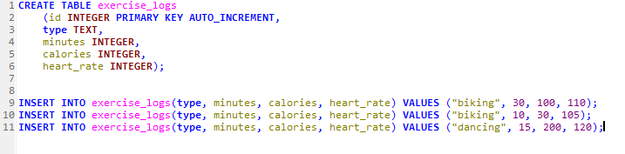

**#** for creating a temporary table

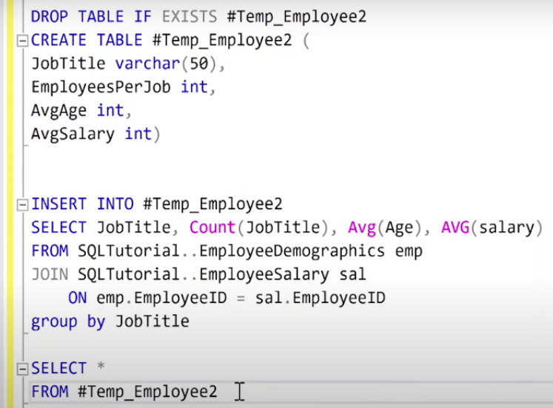

## Usar SELECT

For grouping a column into a single value.

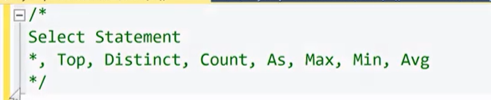



To see just the first **5 rows** of a table with **all de columns**.



We can specify

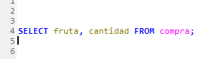

**WHERE** for filtering data, **GROUP BY** for summary data, **ORDER BY** for organizaing data (ASC is no necessary) and **AS** to name a column.

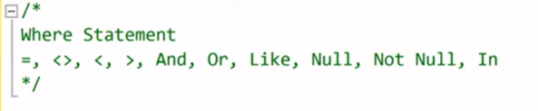

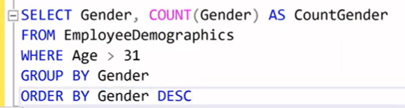

**HAVING** makes the same job that WHERE but it works with agrupated columns.

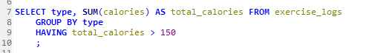

**(NOT) IN** the list requared can be fill by making another select and **(NOT)** **LIKE** for not exact searching.

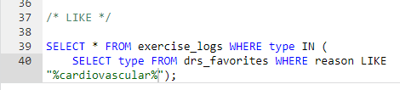

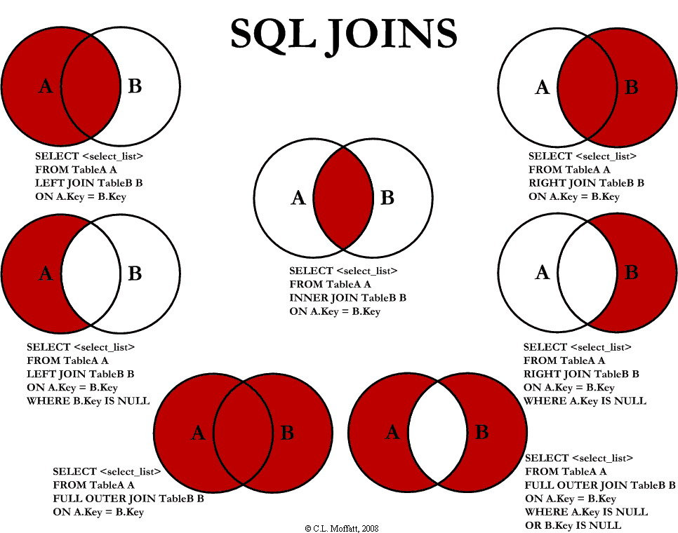

**JOINs**

For avoiding to make to select we just need to no use de alias of column

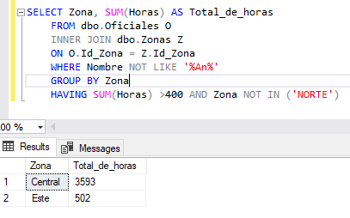

**UNION,** makes cbind in SQL. If we add **all** agregate duplicared rows.

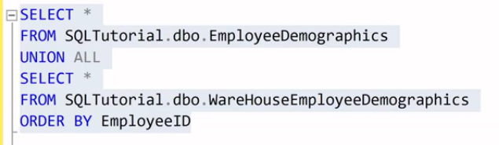

**CASE** function as a nested IF in Excel, but is really easier to understand and it should be aggregated as a column in the function SELECT. I mean separate with a comma.

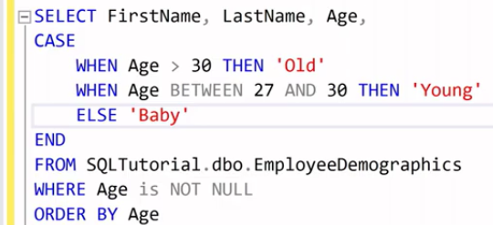

# Combinte to columns and save as Aliasing

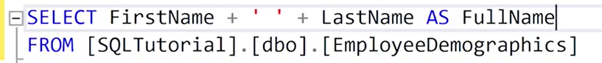

**OVER** and **PARTITION BY** create a windows function.

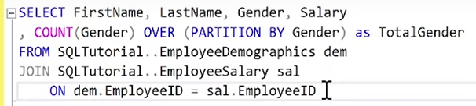

**WITH** and **AS** for avoinding repeat a query many times.

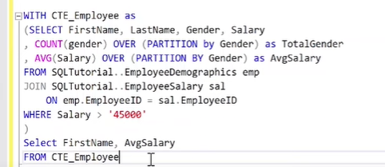

Or

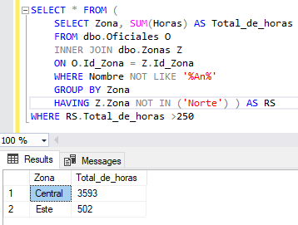

**ROUND** redondea los números tal como hace Excel.

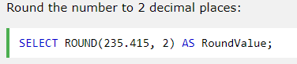

## Update

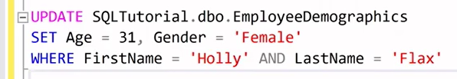

## Delete



But many apps never delete the information, instate they just set a column like True or false for not losing information.

## Alter table

This command allow us to insert a extra column, in this case in the rows before we will see “null” as a value.



In this way we can set another value instead of “NULL”



## Drop table

This command erase the complete table.



## Consejos para no dañar la basa de datos si tengo acceso completo

Before typing a delete o update command, I should run a select with the same WHERE plus the limit operator to be sure that I am editing the correct row.







If I am working in an environment where there are several people making changes at the same time is better to agrupate the commands for all those happen without interruption.

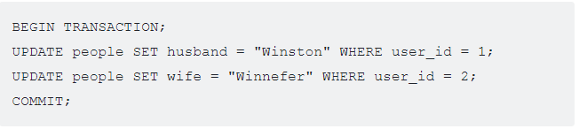

Here's how we can give full access to a particular user:



Here's how we can give only SELECT access to a different user:

